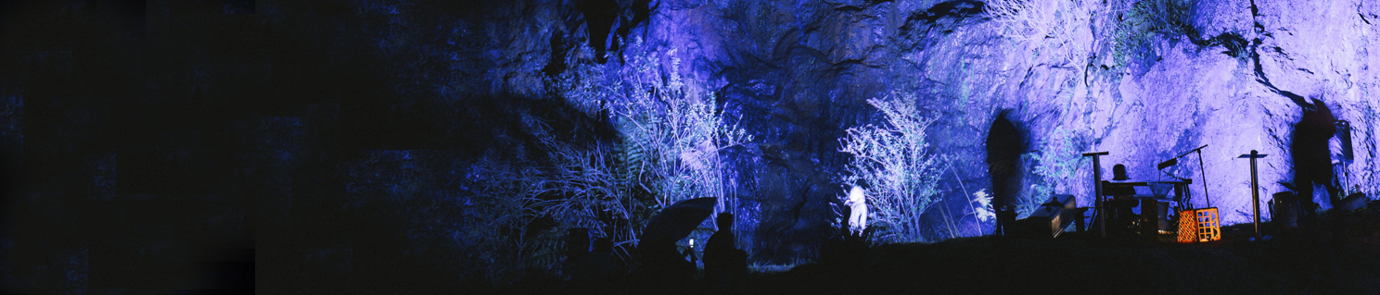
West Coast Artist Seed Funding Program

Information and Application Form for a seed
funding program for West Coast artists in 2018.

General Information
Background
The Unconformity Inc. is a cultural organisation that delivers a range of cultural development and audience outcomes in Queenstown, in Western Tasmania. While our activities are focused upon The Unconformity arts festival (formerly Queenstown Heritage and Arts Festival), a biennial event that will next be held on 19-21 October 2018, The Unconformity also develops and delivers projects outside of the festival. In 2018 these include the development of a visitor smartphone app, investing in event equipment for local community use, multiple arts projects in partnership with Mountain Heights School, an artist residency program, development of the Queenie Muster event, and support projects for local artists.

Seed Funding Program Summary
Through the support of Arts Tasmania, the Unconformity is providing a pool of $5,000 towards local West Coast artists and arts practitioners for development activities or infrastructure.
This fund is to seed the development of local artists, practitioners and groups. Outcomes may include things like travel to attend master classes or exhibitions, skills development, mentoring, small items for infrastructure, or equipment.
Individuals or groups can apply for funds up to $1,250.

Application Form Info
The application form can be found on page 2 of this document.
The applications will be assessed against two criteria:
- The benefit for the artist/group
- The benefit for the West Coast community.

Deadline
The completed application form needs to be submitted either via email attachment to info@theunconformity.com.au by midnight on Friday 6 July 2018, or posted to The Unconformity, PO Box 315, Queenstown, TAS, 7467 by close of business on Friday 6 July 2018.

Assessment
Applications will be independently assessed by a panel of four West Coast people from across the region representing different art forms and cultural experiences, along with an industry representative from the visual art sector.

Contact
If you have any questions on the proposal form, commission details or eligibility, please contact us by emailing info@theunconformity.com.au.

West Coast Artist Seed Funding Program

Information and Application Form for a seed
funding program for West Coast artists in 2018

Application Form
This application form can be typed within the form and submitted via email, or printed and supplied in hard copy.

Individual or group name
Address
Phone number
Email address
Do you or does your group
live on the West Coast?
Who
Provide a short background of who you are and what you or your group does.
What
Things to consider are:
- What is your proposal (what do you want?)
- Who is involved?
- Why do you need seed funding?
How
Please let us know:
- How much will it cost?
- When and how will your proposal happen?
Other Info
Please provide any other details that are relevant to this proposal.
Submission
Email: Send this completed application form to info@theunconformity.com.au by midnight on Friday 6 July 2018.
Post: Please post this completed application form to The Unconformity, PO Box 315, Queenstown, Tasmania, 7467
by close of business on Friday 6 July 2018.

