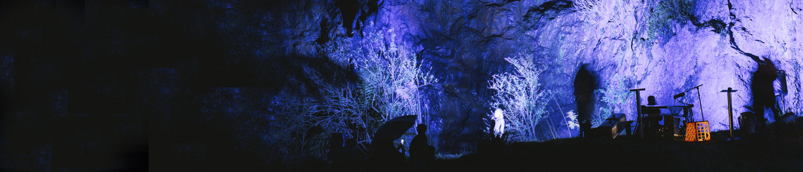
West Coast Artist Seed Funding Program

Information and Application Form for a seed
funding program for West Coast artists in 2019

General Information
Background
The Unconformity is a cultural organisation that delivers a range of cultural development and audience outcomes in Queenstown, in Western Tasmania. While our activities are focused upon The Unconformity arts festival (formerly Queenstown Heritage and Arts Festival), a biennial event that will next be held on October 2020, The Unconformity also delivers projects outside of the festival including investing in event equipment for local community use, youth art projects in partnership with Mountain Heights School, artist in residence programs, and support projects for local artists.

Seed Funding Program Summary
Through the support of Arts Tasmania, The Unconformity is providing a funding pool of $5,000 towards West Coast artists, cultural practitioners and groups for development activities or infrastructure.
Outcomes may include things like travel to attend master classes or exhibitions, skills development opportunities, mentoring, gallery or exhibition infrastructure, or arts-related equipment.
Individuals or groups can apply for funds up to $1,250.

Application Form Info
The application form can be found on page 2 of this document.
The applications will be assessed against two criteria:
- The benefit for the artist/group
- The benefit for the West Coast community.

Support Material
You can supply the following documents as support material either by email or post:
- Up to five .jpeg images
- Quotes or documents relating to project expenditure (no page limit)
- You do not need to supply letters of support with this application.

Deadline
The completed application form needs to be submitted by 5:00pm on Monday 15 July 2019, by one of two means:
- Email — Email your completed application as an attachment to info@theunconformity.com.au
- Post — Send your printed application to The Unconformity, PO Box 235, Queenstown, TAS, 7467.

Assessment
Applications will be independently assessed by a panel representing West Coast people from across the region representing different art forms and cultural experiences, along with industry representatives from the visual art sector.

Contact
If you have any questions on the proposal form, commission details or if you are unsure about your project’s eligibility, please contact us by emailing info@theunconformity.com.au.

West Coast Artist Seed Funding Program

Information and Application Form for a seed
funding program for West Coast artists in 2019

Application Form
This application form can be typed within the form and submitted via email, or printed and supplied in hard copy.

Individual or group name
Address
Phone number
Email address
Do you or does your group
live on the West Coast?
Who
Provide a short background of who you are and what you or your group does.
What
Things to consider are:
- What is your proposal (what do you want?)
- Who is involved?
- Why do you need seed funding?
How
Please let us know:
- How much will it cost?
- When and how will your proposal happen?
Other Info
Please provide any other details that are relevant to this proposal.
Submission
Please submit your application and support material (if required) by email or by post, by 5:00pm on Monday 15 July 2019:
Email: Send this completed application form to info@theunconformity.com.au
Post: Post this completed application form to The Unconformity, PO Box 235, Queenstown, Tasmania, 7467.

